Linköping University | Department of Physics, Chemistry and Biology
Master’s thesis, 60 hp | Educational Programme: Applied Ethology and Animal Biology
Spring term 2021 | LITH-IFM-A-EX – 21/3968 -SE

Domestication effects on social learning in chickens

Austeja Rutkauskaite

Supervisor Prof. Per Jensen
Examiner Asst. prof. Rie Henriksen

Datum
Date

Avdelning, institution
Division, Department

Department of Physics, Chemistry and Biology
Linköping University
URL för elektronisk version
ISBN

ISRN: LITH-IFM-A-EX-21/3960-SE
_________________________________________________________________
Serietitel och serienummer ISSN
Title of series, numbering ______________________________

Språk
Language

Svenska/Swedish
Engelska/English

________________
Rapporttyp
Report category

Licentiatavhandling
Examensarbete
C-uppsats
D-uppsats
Övrig rapport
_____________
Titel
Title

Domestication effects on social learning in chickens

Författare
Author
Austeja Rutkauskaite
Nyckelord
Keywords
Chickens, Cognition, Domestication, Red Junglefowl, Social learning
Sammanfattning
Abstract
Over the course of domestication animals undergo a typical set of morphological changes known as the domesticated phenotype. These include changes in the size of a number of brain areas, suggesting a possible shift in cognitive function. As most domesticated species, chickens are commonly housed in large groups and have been in close contact with humans for thousands of years, making social cognition specifically a potential subject to change. In this behavioural experiment, domesticated chickens (Gallus gallus domesticus) of the White Leghorn breed were compared with their ancestral species, the Red Junglefowl (Gallus gallus), in a cognitive task that involved learning from a pre-trained demonstrating conspecific. Each bird observed 5 demonstrations of pushing away a lid of a puzzle apparatus to reveal a food reward. The observing birds were then given the same puzzle apparatus to attempt the task. It was found that both subspecies picked up information from conspecific demonstrators. When compared, Red Junglefowl were more strongly influenced by the demonstrations and used the information more effectively, while domesticates showed a generally higher motivation to attempt the task. Future research where human demonstrators would be compared with conspecific demonstrators could reveal further differences in social learning in the two subspecies.

Table of Contents

1 Abstract 4
2 Introduction 4
2.1 Domestication and its effects 4
2.1.1 Definition and general effects 4
2.1.2 Effects of domestication on chickens 5
2.2 Social transmission of information among animals 6
2.3 Social behaviour and social cognitive abilities in domestic chickens and Red Junglefowl 7
3 Materials and methods 9
3.1 Ethical note 9
3.2 Sample size and composition 9
3.3 Animal housing 9
3.4 Design of the puzzle apparatus 11
3.5 Preparation and training of demonstrator birds 12
3.6 Testing setup, procedure and recorded behavioural measures 13
3.7 Data analysis 14
4 Results 15
4.1 Demonstrator training and demonstration quality 15
4.2 Puzzle task success and puzzle apparatus-directed behaviour 15
4.3 General activity 19
5 Discussion 21
6 Societal and ethical considerations 24
7 Acknowledgements 25
8 References 26

1 Abstract
Over the course of domestication animals undergo a typical set of morphological changes known as the domesticated phenotype. These include changes in the size of a number of brain areas, suggesting a possible shift in cognitive function. As most domesticated species, chickens are commonly housed in large groups and have been in close contact with humans for thousands of years, thus potentially causing a change in social cognition in these birds. In this behavioural experiment, domesticated chickens (Gallus gallus domesticus) of the White Leghorn breed were compared with their ancestral species, the Red Junglefowl (Gallus gallus), in a cognitive task that involved learning from a pre-trained demonstrating conspecific. Each bird observed five demonstrations of pushing away a lid of a puzzle apparatus to reveal a food reward. The observing birds were then given the same puzzle apparatus to attempt the task. It was found that both subspecies picked up information from conspecific demonstrators. When compared, Red Junglefowl were more strongly influenced by the demonstrations and used the information more effectively, while domesticates showed a generally higher motivation to attempt the task. Future research where human demonstrators would be compared with conspecific demonstrators could reveal further differences in social learning in the two subspecies.

Keywords: Chickens, Cognition, Domestication, Red Junglefowl, Social learning

2 Introduction

2.1 Domestication and its effects

2.1.1 Definition and general effects
Domestication is a process through which wild animals establish a strong symbiotic association with humans and live under human control to some degree. This process is stretched over many generations and involves intentional and unintentional selection, resulting in genetic modifications that set domesticates apart from their wild ancestors (Jensen, 2017). Domestication has been associated with a number of changes in all domesticated species. These changes are often referred to as the domesticated phenotype (Price, 1999; Agnvall et al., 2017). Some examples include changes of morphological traits, such as loss of pigmentation, physiological changes, such as a reduced sexual seasonality as well as behavioural changes, such as a reduced fear of humans (Jensen, 2017).
One morphological change that may simultaneously result in a behavioural one is the difference in brain size. Although whole brain size may change, in many cases the alterations are in agreement with the mosaic evolution hypothesis, where only some brain areas shrink or enlarge (Barton & Harvey, 2000; Rehkämper et al., 2007; Henriksen et al., 2016). Such changes have been seen in domestic pigeons (Rehkämper et al., 2007), ducks (Ebinger, 1995) and chickens (Jackson & Diamond, 1996) as well as Red Junglefowl that were selected for tameness (Agnvall et al., 2017) when compared to their wild counterparts. Thus, the possibility of altered cognitive function as a result of domestication should be investigated.

2.1.2 Effects of domestication on chickens
Based on archaeological evidence, the ancestors of domestic chickens had been closely associating with humans for at least 8000 years (West & Zhou, 1988). However, molecular data indicates the possibility that domestication had begun as early as 58 000 years ago (Sawai et al., 2010). Domestic chickens originate from the Red Junglefowl, a ground-living phasianid species that still inhabits India and Southeast Asia today (Al-Nasser et al., 2007).
Domestic chickens are behaviourally similar to wild Red Junglefowl. As experiments with feral chickens show, they have retained similar daily routines, including, for example, resting in tree branches during the night to avoid predators. Essential behaviours are unchanged as well, since feral chickens have been observed to be effective in foraging, flight and brooding (Wood-Gush & Duncan, 1976). Early stages of domestication likely involved a strong selection for tameness. However, modern domestic chicken selection has mainly been focused on traits that lead to high production, so it is likely that behaviour was not equally heavily influenced by artificial selection (Agnvall & Jensen, 2016; Marino, 2017).
Based on genetic and morphological evidence, the White Leghorn layer breed is among the most similar to the ancestral Red Junglefowl (Collias & Collias, 1996; Moiseyeva et al., 2003). However, intense artificial selection in the 20th century (Al-Nasser et al., 2007) resulted in the egg production sky-rocketing from the 10 to 15 eggs per year seen in the wild, to 300 eggs per year in the laying breeds (Romanov & Weigend, 2001). An increase of that magnitude required changes in the endocrine system and behavioural patterns. Behaviour is, however, strongly conservative unless specifically targeted by selection (Agnvall & Jensen, 2016). Yet, egg-laying breeds tend to have different behavioural time-budgets when compared to Red Junglefowl, where the time spent exploring and roaming is reduced to possibly conserve energy (Lindqvist et al., 2002; Schütz et al., 2002). This may result in the breed being more reluctant to work for food than Red Junglefowl.
Although a change in brain size does not necessarily directly translate to a functional change in behaviour or cognition (Herculano-Houzel, 2010), there are some consistent brain size changes in relation to domestication in chickens. When compared to Red Junglefowl, domestic chickens have smaller brains relative to body size overall. This does not apply to the cerebellum, however, as it is larger in domestic chickens than in Red Junglefowl (Rehkämper et al., 2007; Henriksen et al., 2016). Body size and brain size are not tightly genetically linked (Henriksen et al., 2016), suggesting another, most likely functional reason for the change. This is also supported by observations in barn swallows, where brain size is not related to other body size measurements, such as wing area (Møller, 2010). An enlargement of the cerebellum is also seen in Red Junglefowl that have been selected for low fear of humans (Agnvall et al., 2017), indicating that cerebellum function may play a role in adapting to the domestic environment (Katajamaa et al., 2021). This brain structure has a broader function spectrum than previously assumed. Besides locomotive functions, in mammals the cerebellum is also involved in non-motor associative learning (Bellebaum & Daum, 2011), imitation (Jackson et al., 2006), empathy and predicting actions of others (Ramnani & Miall, 2003; Schulte-Rüther et al., 2007), as well as cognitive performance (Hogan et al., 2011). The exact significance of an enlarged cerebellum is hard to determine, as neuron and synapse density may play an important role (Herculano-Houzel, 2010). Testing cognition through behavioural observations is one way to investigate if this size change has had a functional effect without the need of brain imaging or dissection.

2.2 Social transmission of information among animals
Social learning (or observational learning) is defined as a family of mechanisms by which an individual can copy an observed goal-directed behaviour (Hecht et al., 2012). For example, rats have been shown to learn how to complete a maze after observing a conspecific do it (Zentall & Lavine, 1972). Numerous instances of social learning have been observed in primates. Examples include macaques learning to wash their food from one another (Kawamura, 1959) as well as acquisition of tool use in chimpanzees (Inoue-Nakamura & Matsuzawa, 1997). In birds, songs (Beecher, 2017) and nest-building skills (Guillette et al., 2016) are shaped through social learning.
There are several forms of social information transmission, ranging from low to high in relative complexity. Some effects occur only on the physiological level and are referred to as autonomic self-other matching (Hecht et al., 2012). For example, greylag geese that observe a mate take part in a conflict also experience an increase in heart rate (Wascher et al., 2010). One of the more marked ways behaviours are affected by other group members is through stimulus enhancement, where individuals pay more attention to objects that their conspecifics have been interacting with (Hecht et al., 2012). Similarly, local enhancement occurs when an individual is more likely to visit a location, where it had observed a conspecific staying or performing some behaviour (Dugatkin, 2004; Hoppitt & Laland, 2013). In cases of both stimulus enhancement and local enhancement, each individual determines what the following interaction should be. These phenomena merely result in a greater interest towards an object or location, and the observers may then learn solely from the actions made on their own (Dugatkin, 2004). Another phenomenon, known as social facilitation, often results in group-living animals synchronising their behaviours. As defined by Keeling and Hurnik (1993), it is an initiation or an increase in the intensity or frequency of an animal’s response, when in the presence of a conspecific that is engaged in the same behaviour. In most complex cases of social information transmission, social learning occurs. This is when animals pay attention to the actions of conspecifics and then replicate them (mimicry, overimitation) or try to achieve the same goal that the actions had led to (emulation) or do a combination of both (imitation) (Hecht et al., 2012).

2.3 Social behaviour and social cognitive abilities in domestic chickens and Red Junglefowl
Red Junglefowl and, by extension, the domestic chicken, are a social species. They live in polygynous harems of up to 30 adults in size (Mench & Keeling, 2001) and move more or less as an isolated group in an established territory of brush or forest (Wood-Gush & Duncan, 1976; Collias & Collias, 1996). The flock has a hierarchical system which determines resource distribution (Collias & Collias, 1996) and establishes the role of the dominant cockerel as the individual that protects the group the most (McBride et al., 1969).
This group lifestyle of wild chicken predecessors has led to a development of complex social skills and learning abilities. Chickens can recognise each other (Bradshaw, 1991). They do this using several different sources of information, such as unique voice calls (Smith et al., 2016), visual features, through inspecting the head and neck area at close proximity (Candland, 1969, Dawkins, 1995; Dawkins, 1996), and olfactory information (Abeyesinghe et al., 2009). Social relationships in the flock are based on this recognition and suggest a cognitive capability to understand and use identities (Smith et al., 2016). Additionally, these birds show a degree of perspective-taking, at least in terms of being aware of their audience when making calls (Karakashian et al., 1988) and the affective state of their conspecifics (Johnston et al., 1998).
Social learning has been observed within flocks, as chickens are able to pick up information from conspecifics. This includes learning to avoid unpleasant stimuli after observing others experience them (Johnston et al., 1998) as well as learning new behaviours in order to obtain food rewards (Nicol & Pope, 1992). A stimulus can be novel and completely meaningless, but the birds pay attention to how a conspecific reacts to it. For example, pecking at a bead coated in a bitter substance elicits a strong disgust response (shaking of the head, wiping the beak, etc.) that informs it should be avoided and creates a long-lasting passive avoidance in the observer (Johnston et al., 1998). On the other hand, a rewarded novel behaviour, such as pecking at a specific key, can be associated with a positive outcome and learned as a new foraging technique (Nicol & Pope, 1992; Nicol & Pope, 1999).
Domestic chickens had been living under reduced predator pressure for thousands of years. During this time, gathering information from conspecifics could have lost some of its original significance, due to human protection (Brokordt et al., 2006; Solberg et al., 2020). The domestic White Leghorns have been previously shown to have social learning abilities inferior to those in Red Junglefowl (Lindqvist et al., 2002). This is despite the fact that this domestic breed has retained the same qualitative repertoire of social signals (Väisänen et al., 2005). As social signalling is less crucial for survival in a human-protected area than it is in an unpredictable jungle, social learning may have become reduced in domestic chickens when compared to Red Junglefowl. A comparison of performance in a cognitive task that is based on social learning could reveal what differences exist between modern domestic chickens and their wild counterparts.

The main goal of this experiment was to assess whether Red Junglefowl (RJF) and White Leghorn layers (WLs) are able to learn a puzzle apparatus-opening task from a demonstrating conspecific and determine if notable differences in social learning exist between the two subspecies. This goal was to be achieved through fulfilling several aims:
- To assess and compare the abilities of WLs and RJF to pick up information from a conspecific and use that information to solve a puzzle task,
- To compare the level of motivation to obtain a food reward in birds of both subspecies that observed a conspecific obtain it (“guided”) and birds that did not observe one (“naïve”) through assessing the number of interactions with the puzzle apparatus,
- To detect and compare other effects of the presence or absence of conspecific demonstrations on WLs and RJF by recording general behavioural patterns throughout the duration of the test trial.
I hypothesised that RJF and WLs will differ in their ability to acquire information from a conspecific.

3 Materials and methods

3.1 Ethical note
The experiment was performed in accordance to regulations for animal experiments in Swedish and European law. It was carried out with approval from Linköping Council for Ethical Licensing of Animal Experiments, under the ethical permit no. 14916-2018. The experiment took place during the period September 25th to November 15th, 2020.

3.2 Sample size and composition
The sample consisted of 53 adult (15 to 19 months of age during the course of the experiment) female birds (observers). Of these, 12 were White Leghorns (WLs; hatched in May, 2019; bred from the SLU13 line, which originated from experimental breeding described in Liljedahl et al., 1979) and 41 were Red Junglefowl (RJF; hatched in April, 2019 from a line that originated from a Swedish zoo population, as described in Schütz et al., 2001). These birds fell into four groups: five naïve WLs (WL controls), seven “guided” WLs, 20 naïve RJF (RJF controls), and 21 “guided” RJF.
Additionally, two pre-trained female demonstrator birds (demonstrators) were used. There was one demonstrator for each of the two subspecies and each demonstrated only to their respective subspecies. These demonstrator birds had been selected with prior observation, picking the individuals of a high hierarchical rank in hopes of ensuring better learning outcomes (Nicol & Pope, 1994; Nicol & Pope, 1999). Observers and demonstrators were familiar with each other for the same reason, as encountering strangers is a negative experience for chickens (Nicol & Pope, 1994; Grigor et al., 1995).

3.3 Animal housing
Between tests the birds of both subspecies used in this study were housed in 9 m² (3 x 3 x 3 m, L x W x H) sized pens with access to an outside pen of the same size (3 x 3 x 3 m) in a single sex group of 57. The birds had ad libitum access to commercial chicken food pellets, mussel shells, water (through a water nipple) and wood chips as substrate. Additionally, starting at 4 weeks prior to testing, mock puzzle apparatus bases (Figure 1) were filled with canned sweet corn daily and placed in varying locations inside the home pen. Sweet corn was used during tests as a food reward, so this was done to ensure all birds were familiar with it. Besides that, the pens were enriched with a long perch, platforms of different height, nest boxes and supplementary foods, such as carrots and apples. The birds were exposed to a 12 hour light-darkness cycle in the indoor part of the enclosure. Light intensity was about 10 lux. The indoor temperature was maintained at around 20 °C.

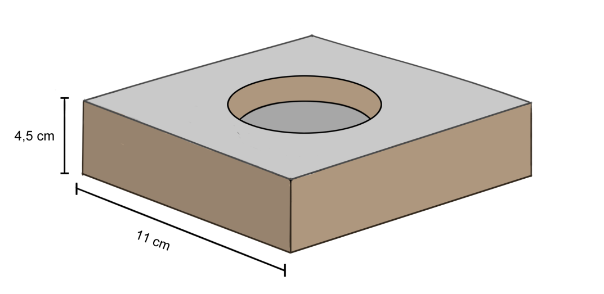
Figure 1. An illustration of a mock puzzle apparatus base, used to habituate the birds to the puzzle apparatus and familiarise them with the food reward in their home pen.

During the course of the experiment, the birds had each spent 22.8 hours on average habituating to a smaller testing pen of 1.77 m² (94 x 188 x 179 cm). This pen consisted of two connected chambers (94 cm x 94 cm x 179 cm), which were kept separated by a see-through wire mesh on one side and a solid cardboard wall on the other (Figure 2). Environmental conditions in the testing pen were similar to those in the home pen. Ad libitum access to commercial chicken food and water in an open container was provided. The floor was covered in a layer of fine wood chips. The birds were exposed to a 12 hour light cycle, with a light intensity of about 10 lux. The temperature was maintained at around 20 °C.
The testing procedure would take place in the afternoon (between 1 pm and 4 pm). Every bird had a conspecific companion in the connected chamber of the testing pen at all times. At the end of the habituation period, the testing procedure began, after which the observing bird (or both birds in the case of the control group) was returned to the home pen.

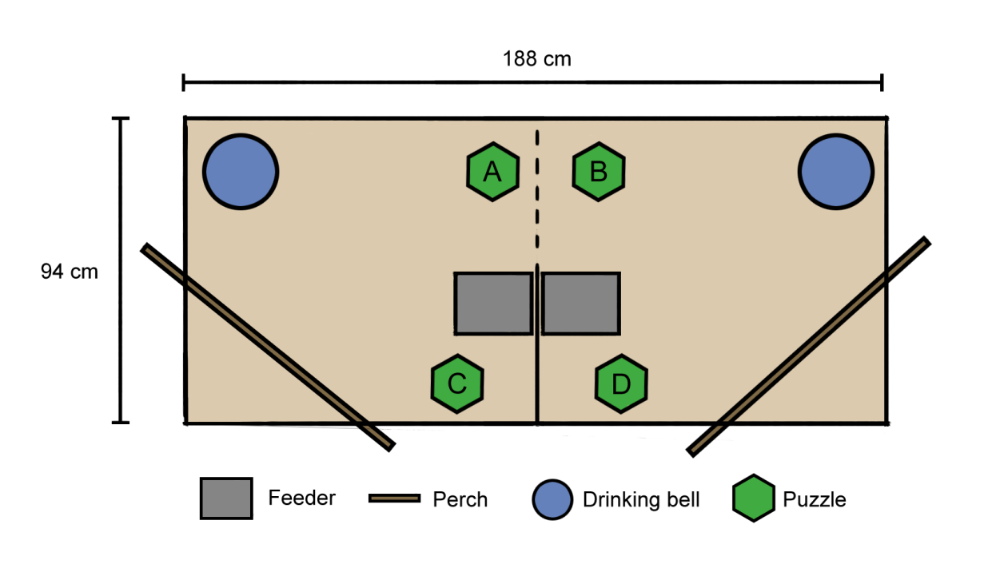
Figure 2. A diagram representing the testing pen and object layout within it. The dashed line indicates a wire mesh partition. The letters represent the different positions of the puzzle apparatus throughout the experiment: A – puzzle apparatus placement during demonstrations (within 5 cm of the wire mesh), B – puzzle apparatus placement during guided trials, C and D – puzzle apparatus placement during naïve trials.

3.4 Design of the puzzle apparatus
The puzzle apparatus (Figure 3, A) consisted of a heavy baseplate with a circular dish in the middle, in which food rewards were placed. A transparent perforated Plexiglas lid covered this baseplate. It was attached with a screw in the top centre part, allowing it to be twisted away to either side to reveal a food reward (Figure 3, B). Rubber lining was attached to the edges of the lid, allowing for better grip and higher visual contrast in the video footage.

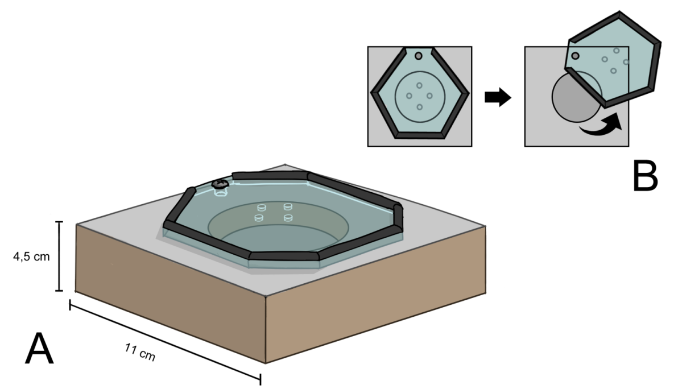
Figure 3. An illustration of the puzzle apparatus used in the experiment (A) and a schematic representation of how the lid would be horizontally twisted to reveal the dish below (B).

3.5 Preparation and training of demonstrator birds
Prior to all training, the animals had spent 30 min in the empty testing area, allowing them to explore it. This was done to reduce the probability of fear responses, which could negatively affect learning outcomes (de Haas et al., 2017). Additionally, a companion bird in the connected chamber served as a mock observer during training sessions. Demonstrators could be significantly affected by conspecific presence (Nicol & Pope, 1994), and this allowed the demonstrators to become comfortable with conspecifics observing the puzzle-solving process.
Demonstrators were trained to consistently solve the puzzle task before testing had begun. The learning criterion was set at the ability to respond correctly ten times in a row. To assist learning the puzzle apparatus was presented in several stages of increasing difficulty. Training lasted six to eight days, from one to three hours each day with breaks between trials. Each trial would consist of the puzzle apparatus being placed down with the food reward in the dish and would end either when all of the food was eaten or after 10 min of no interaction with the puzzle apparatus. In the first few sessions, the birds received the puzzle apparatus with the lid fully or partially pushed away. In the first three days of training, the sessions were shorter, with only 10 to 24 trials per day. As training continued, demonstrators showed greater and greater motivation in solving the puzzle task, doing an average of 42 trials per day. During this time, the puzzle apparatus would be presented with an almost closed or a fully closed lid.

3.6 Testing setup, procedure and recorded behavioural measures
A small camera (GoPro Hero 5 Black) was placed on the mesh roof of the testing pen to record all trials. The body of the camera was hidden behind a cardboard casing and only the lens was visible. The cardboard casing itself would remain placed on the roof at all times, so as to minimise potential fear reactions towards the camera during testing.
During testing trials with demonstrations, the puzzle apparatus was placed within a 10 cm distance from the wire mesh (Figure 2, A) to allow for a thorough visual inspection of the demonstrating bird (Dawkins, 1995; Dawkins, 1996). A single demonstration consisted of the demonstrator bird approaching the puzzle apparatus and moving the lid to obtain the food reward (sweet corn). This demonstration was repeated 5 times by picking up the puzzle apparatus, refilling it with the food reward and then placing it down again in the designated location. After the demonstrations, the refilled puzzle apparatus was given to the observing (“guided”) bird (Figure 2, B) to attempt to complete the task of opening the lid. The experimenter then left the room so as not to influence the test outcome. Birds had access to the puzzle apparatus for 30 minutes. If the bird opened the puzzle lid completely, the test was terminated early.
The control trial procedure was similar to that described above, except no demonstrations took place. Both chambers held a control (“naïve”) bird each. The puzzle apparatus was filled with food and placed by the solid cardboard partition, behind the metal feeder (Figure 2, C, D) to ensure that only one bird at a time would be able to see it. As in guided trials, control birds had access to the puzzle apparatus for 30 minutes and the experimenter would leave the room during this time.
During all trials, several behavioural measures were extracted from the video recordings (Table 1). General activity behaviours were recorded over the 30 minute period using the one-zero sampling technique (Lehner, 1992) at 1 min intervals (Table 1, Table 2).

Table 1. Behavioural measures extracted from video recordings of the test.
Behavioural measure
Latency to approach the puzzle apparatus (head within 5 cm) (s)
Furthest lid position attained (%)
Time taken to attain furthest lid position (s)
Number of pecks directed at the puzzle apparatus (n)
Number of time the puzzle apparatus was approached (n)
General activity (number of 1 min intervals) *
* general activity behaviours are listed in Table 2.

Table 2. The ethogram used for general activity behaviours that were tracked with 1/0 sampling over the 30 minute test period.
Behaviour | Description
Interacting with the puzzle apparatus | The bird approaches or pecks at the puzzle apparatus.
Foraging | Standing or walking slowly with head low to the ground, pecking at the floor and picking out particles out of the substrate. Pecking is periodically interrupted by scratching at the ground to reveal more particles.
Preening | The beak is run over the feathers rhythmically on various parts of the body. The bird also periodically leans back towards the uropygial gland to obtain its secretions.
Feeding (from the feeder) | The bird picks up or pecks at the food pellets inside the metal feeder box.
Lying down | The legs are bent underneath the body; the body is lowered and pressed against the floor.
Dust-bathing | The body is lowered and pressed against the floor. The bird pushes substrate towards itself with the beak. The birds are fluffed up and substrate is spread over the feathers. The birds may also roll on the side and rub against the substrate.
Drinking | The bird dips its beak into the water to fill it up and periodically lifts its head to swallow the water.

3.7 Data analysis
The normality of latency data was determined through visual inspection of Q-Q plots and by using the Shapiro-Wilk W test at a significance threshold of p < 0.05. Outliers were identified using the Tukey’s fences method at a boundary distance of 1.5 interquartile range.
The proportion of successes and failures in moving the lid were compared between treatment groups (guided and naïve) and subspecies (RJF and WL) using the χ² test at a significance threshold of p < 0.05. Effect size was determined using the φ (Phi) coefficient. The relationships between the furthest puzzle lid position achieved and the total number of pecks as well as approaches and approach latency were tested using Spearman’s rank correlation coefficient.
The relationship between other behavioural measures (approach latency, number of pecks, number of approaches, general activity) and treatment group as well as subspecies were analysed using Generalised Linear Models (GLM) with The Wald χ² at a significance threshold of p < 0.05. Approach latency was log transformed with a base power of ten to adhere to normal distribution and modelled as a normally distributed dataset. All other behavioural measures were modelled with the negative binomial distribution.
Statistical analyses were performed using IMB SPSS Statistics (version 27) software. Graphs were created using Microsoft Excel (2010).

4 Results

4.1 Demonstrator training and demonstration quality
Both demonstrator birds passed the learning criterion. The RJF demonstrator fulfilled it after 164 training trials over six days, while the WL did so after 104 trials over eight days. Demonstrators showed high motivation and successfully opened the puzzle apparatus in every test trial over the course of the experiment. All but one of the 28 observing birds in guided trials showed great interest in the demonstrations, most often attempting to get through the wire mesh.

4.2 Puzzle task success and puzzle apparatus-directed behaviour
Only five (RJF n = 2; WL n = 3) out of 53 sampled birds over both treatment groups opened the puzzle lid completely with an average of 58.8 pecks required to do so. The average time taken to open the puzzle lid was 117.4 s. A total of 17 individuals (RJF n = 10, WL n = 7) moved the puzzle lid at least partially (Figure 4). Treatment had a significant (χ² test; Likelihood Ratio₍₁₎ 4.64; p = 0.031) moderate (χ² test; φ = 0.372) effect on success rate only in RJF, with the guided group being more likely to open or move the lid than the naïve group. No significant differences in success rate were found between treatment groups in WL (χ² test; Likelihood Ratio₍₁₎ 1.20; p = 0.274) or when comparing the two subspecies of the same treatment group (guided χ² test; Likelihood Ratio₍₁₎ 2.39; p = 0.122; naïve Likelihood Ratio₍₁₎ 2.25; p = 0.134).

Figure 4. The furthest lid position achieved during the test in each treatment group and subspecies. Data is displayed in relative proportions, as group sizes differed from one another. Numbers inside the bars represent the number of individuals in that category. 0 % ‒ the lid was not moved, 25 % ‒ the lid was moved slightly, but its edge does not reach the edge of the food dish, 50 % ‒ the edge of the lid aligns with the edge of the food dish, 75 % ‒ the lid reveals a portion of the food dish, 100 % ‒ the lid reveals the food dish completely or enough to access the food inside.

There were significant differences in approach latency between the two treatment groups and the two subspecies (Figure 5). In both subspecies, naïve groups were significantly (GLM; Wald χ²₍₁₎ = 24.03; p < 0.001) slower than guided groups. RJF were significantly (GLM; Wald χ²₍₁₎ = 17.21; p < 0.001) slower to approach the puzzle apparatus than WLs.

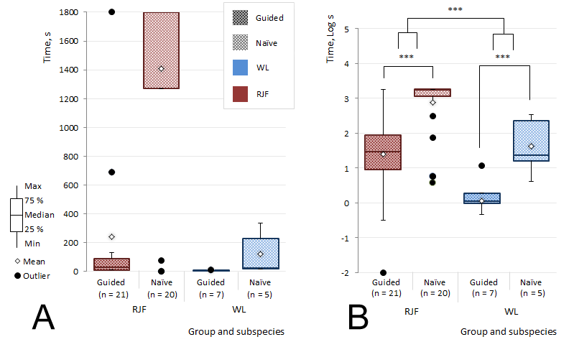
Figure 5. Time taken to approach the puzzle apparatus within 5 cm for the first time during the test by Red Junglefowl (RJF) and White Leghorns (WL) of both treatment groups. Both the time recorded during testing (A) and the log transformed values used in statistical analysis (B) are given. *** indicates statistically significant differences at p < 0.001.

There were also significant effects of both subspecies and treatment group on the number of pecks directed at the puzzle apparatus (Figure 6) as well as to the number of times the puzzle apparatus was approached (Figure 7). Guided birds pecked at the puzzle apparatus significantly (GLM; Wald χ²₍₁₎ = 19.63; p < 0.001) more than naïve ones. WLs pecked at the puzzle apparatus significantly (GLM; Wald χ²₍₁₎ = 13.91; p < 0.001) more than RJF. The number of pecks significantly (Spearman's rank correlation coefficient; p < 0.05) positively correlated (Spearman’s ρ = 0.63) with a further puzzle lid position only in the guided RJF group.

Figure 6. The number of pecks directed at the puzzle apparatus by Red Junglefowl (RJF) and White Leghorns (WL) in each treatment group. *** indicates statistically significant differences at p < 0.001.

The differences in the number of approaches followed similar trends to the previously described number of pecks, but on a less extreme level. Guided groups approached the puzzle apparatus significantly (GLM; Wald χ²₍₁₎ = 7.46; p = 0.006) more times than naïve birds. WLs approached the puzzle apparatus significantly (GLM; Wald χ²₍₁₎ = 9.73; p = 0.002) more than RJF.

Figure 7. The number of times Red Junglefowl (RJF) and White Leghorns (WL) from both treatment groups approached the puzzle apparatus (5 cm distance threshold). ** indicates statistically significant differences at p < 0.01.

4.3 General activity
The birds‘ general activity during the 30 minute test, which was assessed through one-zero sampling, revealed some significant differences between the treatment groups as well as the subspecies. Birds in the guided groups spent significantly (GLM; Wald χ²₍₁₎ = 7.28; p = 0.007) more time interacting with the puzzle apparatus, than those in naïve groups (Figure 8). In both treatments, WLs would interact with the puzzle apparatus significantly (GLM; Wald χ²₍₁₎ = 9.58; p = 0.002) more than RJF. The interaction between treatment group and subspecies was also significant (GLM; Wald χ²₍₁₎ = 4.49; p = 0.034).

Figure 8. The number of 1 min intervals during which Red Junglefowl (RJF) and White Leghorns (WL) of both treatment groups interacted (approached or pecked) with the puzzle apparatus. ** indicates statistically significant differences at p < 0.01.

Guided birds spent significantly (GLM; Wald χ²₍₁₎ = 12.21; p < 0.001) more time feeding from the feeder than naïve birds (Figure 9). Subspecies did not have a significant effect on time spent feeding, however. Other recorded activities (foraging, drinking, preening, perching, lying down and dust-bathing) did not significantly differ between treatment groups or subspecies.

Figure 9. The number of 1 min intervals during which Red Junglefowl (RJF) and White Leghorns (WL) of both treatment groups fed from the feeder. *** indicates statistically significant differences at p < 0.001.

5 Discussion
There were notable differences between treatment groups in the success in opening the puzzle apparatus. Both treatment and subspecies were significant factors in the number of puzzle apparatus interactions, indicating that all guided birds picked up some information from demonstrations, but RJF and WLs are affected differently.
Overall, most birds were not successful with completing the task, as only five individuals opened the puzzle apparatus entirely, while less than half (17 individuals) managed to move the lid at all. The transparent lid reveals the reward, creating motivation to obtain it, but seeing the reward may distract from memorising a demonstrator’s movements. In humans and chimpanzees, puzzle task executions differ based on whether the puzzle box is transparent or not. Opaque versions of the puzzle box lead to a closer imitation of a demonstrator’s movements (Horner & Whiten, 2005). It is possible that each bird was applying their individual technique to opening the lid instead of directly imitating the demonstrator. Keeping in mind that chickens do master a level of object permanence, even at a young age (Regolin & Vallortigara, 1995), an alternative opaque puzzle apparatus design could be tested in the future to specifically differentiate between stimulus enhancement towards food items and the amount of information acquired from a conspecific in the form of movements.
The low level of success is likely not to be due to satiation. Sweet corn appeared to be highly desirable by the birds and it had been previously shown that food deprivation does not lead to better learning outcomes in chickens (Nicol & Pope, 1994). In fact, there is evidence food deprivation may reduce social learning (Nicol & Pope, 1993), so it is not recommended.
Live demonstrations from conspecifics introduce an additional level of variation. Not only does the demonstrator behave slightly differently in every trial, but the amount of attention paid by the observer as a result of said behaviour may also vary (McQuoid & Galef, 1993; Abeyesinghe et al., 2009). Although this was not done in the current experiment, research indicates that the presence of an untrained conspecific alone does not lead to improved learning and is equivalent to a control treatment without any demonstrations (Nicol & Pope, 1992). The fact that guided groups showed significantly increased efforts to open the puzzle apparatus and had higher success in moving the lid suggests that live demonstrations were effective.
Demonstrations had a larger effect on RJF than it did on WLs, as the difference in the number of interactions with the puzzle apparatus between the treatment groups was more pronounced in RJF compared to WLs. RJF may be better adapted to an unpredictable environment in the wild, making signals from conspecifics a high priority. The large increase in motivation to interact with the puzzle apparatus in the guided RJF group compared to the naïve group indicates that RJF are affected by stimulus enhancement more than WLs. As the birds were pecking directly at the lid and not in random areas around the puzzle apparatus, a more generous interpretation would suggest guided birds were intentionally imitating the demonstrators, rather than merely being affected by stimulus enhancement (Nicol & Pope, 1992). Besides becoming more motivated after the demonstration, RJF seemed to also be more effective in using the information provided by the demonstration. It is indicated by the fact that the number of pecks that guided RJF made positively correlated with a further lid position. This is in agreement with previous research which suggests that WLs may have a lesser learning capacity than RJF (Lindqvist et al., 2002). Stimulus enhancement is considered to be a short-term effect (McQuoid & Galef, 1992), so a repetition of the test procedure after a period of time has passed would provide further evidence that social learning had occurred.
Another possible reason RJF were more affected by the demonstration is that the puzzle apparatus was viewed as a potentially threatening novel object to some degree. Although the birds had been fed sweet corn in their home pens in similar looking dishes, naïve RJF may have chosen not to take the risk of investigating an object placed by the experimenter. Additionally, guided RJF were likely more comfortable around the puzzle apparatus because the demonstrator displayed no stress responses, indicating that it is safe. Fearful chickens are more sensitive to changes in the environment and take longer to respond (de Haas et al., 2017), which is why the naïve group may have been at a disadvantage. Over the course of domestication chickens seemingly developed a lowered response to fear-inducing stimuli. RJF that had been selected for a low fear of humans were also generally more explorative (Katamajaa et al., 2018) as well as more bold around a novel object when compared to a more fearful artificially selected line (Agnvall et al., 2015). It has been previously found that WLs have relatively larger cerebelli than RJF (Henriksen et al., 2016). A larger cerebellum in RJF has been linked to better memory of fear-inducing stimuli and a greater tolerance of said stimuli (Katajamaa et al., 2021). Thus, cerebellum size may have increased over the course of domestication and affected the fear response in chickens. This further suggests that domestic chickens may have an advantage in obtaining food from new sources as they are more likely to be bold enough to approach them, as was confirmed by the current experiment.
Observing the demonstrations seemed to motivate the birds to feed, as guided birds of both subspecies used the feeder longer than naïve birds. However, demonstrations did not promote contrafreeloading, since no differences were found in time spent foraging. It had been previously demonstrated that RJF tend to contrafreeload more than WLs (Lindqvist et al., 2002), but no such difference was observed in the current experiment. In fact, it could be argued that WLs worked more for the food reward, as WLs of both treatment groups had directed more pecks at the puzzle apparatus than RJF did. This may be because WLs are inherently more food motivated than RJF, due to the high energy requirements of frequent egg-laying (Romanov & Weigend, 2001).
It is possible that over the course of domestication chickens would have become more effective in picking up information from humans when compared to the ancestral RJF. As found in the current experiment, RJF are affected more by conspecific demonstrations than WLs. However, WLs may have expanded their social cognition to include humans, which could compensate for the relative loss of attentiveness towards conspecifics. In future research, a similar puzzle task that is equal in difficulty to that used in the current experiment could be demonstrated by a human experimenter to help determine whether WLs have an advantage in social learning from humans when compared to RJF.
It is important to note that the current study only used female birds and thus any potential sex differences in social learning remain unexplored. The choice to not use male birds was related to frequent tidbitting behaviour, which could have inaccurately reflected a lower motivation to open the puzzle apparatus to obtain the food reward. Investigations of sex differences in birds in relation to learning have mostly revolved around birdsongs or migration effectiveness. It has been shown that the two sexes socially learn songs at different paces; however, it is unknown if it is caused by anatomical differences, distinct hormonal fluctuations or different learning strategies as well as sensitive periods (Riebel, 2016). Social learning is also said to play a role in learning migratory patterns in migratory birds, however, sex does not appear be a notable factor (Mueller et al., 2013). As no clear trends in sex differences with regard to social learning have been found in birds, future studies of conspecific demonstrations that include both males and females could be informative.
To conclude, female RJF and WLs are both able to acquire information about a new food source involving a cognitive task from observing a conspecific. However, there are considerable differences between the two subspecies in social learning, with RJF being more affected by conspecific demonstrations than WLs. The concept should be explored further by comparing conspecific demonstrators with human demonstrators to investigate if domestication has resulted in a change in the amount of information domestic chickens pick up from humans when compared to the ancestral RJF.

6 Societal and ethical considerations
Domestication is known to have several universal effects on animal species that result in the domesticated phenotype (Price, 1999; Agnvall et al., 2017). Because this typical phenotype is seen across different species, changes in social cognition similar to those seen in chickens may have also occurred in other domesticates. Thus, information on a shift in learning abilities in one domesticated species may shine a light on possible tendencies in other domesticated animals.
Welfare is a constant concern when it comes to domesticated animals, as they are commonly kept in conditions far removed from the environment of their wild counterparts. Studying the cognitive abilities of animals provides information that significantly impacts the public’s attitude towards domesticated species, because an animal’s mind is a highly important factor when forming opinions on animal use (Knight et al., 2004). In turn, as pressure from the public increases, it may lead to improvements in the care provided for domesticates kept in industrial farm conditions. Considering that chickens are the most numerous of all domesticates today (Pizzari, 2016), any positive development in the farming industry can have an impact on billions of lives.

7 Acknowledgements
I would like to thank my supervisor, Per Jensen, for their support, advice and recommendations. I am grateful to my examiner, Rie Henriksen, as well as my colleagues John O’Riordan and Gabriel Aritz Robinson Gonzalez for their critique and feedback. Lastly, I thank Enya Van Poucke for their guidance and knowledge in chicken care.

8 References
- Abeyesinghe, S. M., McLeman, M. A., Owen, R. C., McMahon, C. E., & Wathes, C. M. (2009). Investigating social discrimination of group members by laying hens. Behavioural processes, 81, 1-13.
- Agnvall, B., Bélteky, J., & Jensen, P. (2017). Brain size is reduced by selection for tameness in Red Junglefowl – correlated effects in vital organs. Scientific reports, 7, 1-7.
- Agnvall, B., & Jensen, P. (2016). Effects of divergent selection for fear of humans on behaviour in Red Junglefowl. PloS one, 11, e0166075.
- Agnvall, B., Katajamaa, R., Altimiras, J., & Jensen, P. (2015). Is domestication driven by reduced fear of humans? Boldness, metabolism and serotonin levels in divergently selected Red Junglefowl (Gallus gallus). Biology letters, 11, 20150509.
- Al-Nasser, A., Al-Khalaifa, H., Al-Saffar, A., Khalil, F., Albahouh, M., Ragheb, G., Al-Haddad, A., & Mashaly, M. (2007). Overview of chicken taxonomy and domestication. World's Poultry Science Journal, 63, 285-300.
- Barton, R. A., & Harvey, P. H. (2000). Mosaic evolution of brain structure in mammals. Nature, 405, 1055-1058.
- Beecher, M. D. (2017). Birdsong learning as a social process. Animal Behaviour, 124, 233-246.
- Bellebaum, C., & Daum, I. (2011). Mechanisms of cerebellar involvement in associative learning. Cortex, 47, 128-136.
- Bradshaw, R. H. (1991). Discrimination of group members by laying hens Gallus domesticus. Behavioural processes, 24, 143-151.
- Brokordt, K. B., Fernández, M., & Gaymer, C. F. (2006). Domestication reduces the capacity to escape from predators. Journal of Experimental Marine Biology and Ecology, 329(1), 11-19.
- Candland, D. K. (1969). Discriminability of facial regions used by the domestic chicken in maintaining the social dominance order. Journal of comparative and physiological psychology, 69, 281.
- Collias, N. E., & Collias, E. C. (1996). Social organization of a Red Junglefowl, Gallus gallus, population related to evolution theory. Animal Behaviour, 51, 1337-1354.
- Dawkins, M. S. (1995). How do hens view other hens? The use of lateral and binocular visual fields in social recognition. Behaviour, 132, 591-606.
- Dawkins, M. S. (1996). Distance and social recognition in hens: implications for the use of photographs as social stimuli. Behaviour, 133, 663-680.
- de Haas, E. N., Lee, C., & Rodenburg, T. B. (2017). Learning and judgment can be affected by predisposed fearfulness in laying hens. Frontiers in Veterinary Science, 4, 113.
- Dugatkin, L. A. (2003). Principles of animal behavior. 1st Edition. W. W. Norton & Company, U.S.A., p. 154-155.
- Ebinger, P. (1995). Domestication and plasticity of brain organization in mallards (Anas platyrhynchos). Brain, behavior and evolution, 45, 286-300.
- Grigor, P. N., Hughes, B. O., & Appleby, M. C. (1995). Social inhibition of movement in domestic hens. Animal Behaviour, 49, 1381-1388.
- Guillette, L. M., Scott, A. C., & Healy, S. D. (2016). Social learning in nest-building birds: a role for familiarity. Proceedings of the Royal Society B: Biological Sciences, 283, 20152685.
- Hecht, E. E., Patterson, R., & Barbey, A. K. (2012). What can other animals tell us about human social cognition? An evolutionary perspective on reflective and reflexive processing. Frontiers in Human Neuroscience, 6, 224.
- Henriksen, R., Johnsson, M., Andersson, L., Jensen, P., & Wright, D. (2016). The domesticated brain: genetics of brain mass and brain structure in an avian species. Scientific reports, 6, 1-9.
- Herculano-Houzel, S. (2010). Coordinated scaling of cortical and cerebellar numbers of neurons. Frontiers in neuroanatomy, 4, 12.
- Hogan, M. J., Staff, R. T., Bunting, B. P., Murray, A. D., Ahearn, T. S., Deary, I. J., & Whalley, L. J. (2011). Cerebellar brain volume accounts for variance in cognitive performance in older adults. Cortex, 47, 441-450.
- Hoppitt, W., & Laland, K. N. (2013). Social learning: an introduction to mechanisms, methods, and models. Princeton University Press, p. 66.
- Horner, V., & Whiten, A. (2005). Causal knowledge and imitation/emulation switching in chimpanzees (Pan troglodytes) and children (Homo sapiens). Animal cognition, 8, 164-181.
- Inoue-Nakamura, N., & Matsuzawa, T. (1997). Development of stone tool use by wild chimpanzees (Pan troglodytes). Journal of comparative psychology, 111, 159.
- Jackson, S., & Diamond, J. (1996). Metabolic and digestive responses to artificial selection in chickens. Evolution, 50, 1638-1650.
- Jackson, P. L., Meltzoff, A. N., & Decety, J. (2006). Neural circuits involved in imitation and perspective-taking. Neuroimage, 31, 429-439.
- Jensen, P. (Ed.). (2017). The Ethology of Domestic Animals: An Introductory Text. 3rd Edition. Cabi, p. 21-23.
- Johnston, A. N., Burne, T. H., & Rose, S. P. (1998). Observation learning in day-old chicks using a one-trial passive avoidance learning paradigm. Animal Behaviour, 56, 1347-1353.
- Karakashian, S. J., Gyger, M., & Marler, P. (1988). Audience effects on alarm calling in chickens (Gallus gallus). Journal of Comparative Psychology, 102, 129.
- Katajamaa, R., Larsson, L. H., Lundberg, P., Sörensen, I., & Jensen, P. (2018). Activity, social and sexual behaviour in Red Junglefowl selected for divergent levels of fear of humans. PloS one, 13, e0204303.
- Katajamaa, R., Wright, D., Henriksen, R., & Jensen, P. (2021). Cerebellum size is related to fear memory and domestication of chickens. Biology Letters, 17, 20200790.
- Kawamura, S. (1959). The process of sub-culture propagation among Japanese macaques. Primates, 2, 43-60.
- Keeling, L. J., & Hurnik, J. F. (1993). Chickens show socially facilitated feeding behaviour in response to a video image of a conspecific. Applied Animal Behaviour Science, 36, 223-231.
- Knight, S., Vrij, A., Cherryman, J., & Nunkoosing, K. (2004). Attitudes towards animal use and belief in animal mind. Anthrozoös, 17, 43-62.
- Lehner, P. N. (1992). Sampling methods in behavior research. Poultry science, 71, 643-649.
- Liljedahl, L. E., Kolstad, N., Sørensen, P., & Maijala, K. (1979). Scandinavian selection and crossbreeding experiment with laying hens: I. background and general outline. Acta Agriculturae Scandinavica, 29, 273-286.
- Lindqvist, C., Schütz, K., & Jensen, P. (2002). Red jungle fowl have more contrafreeloading than white leghorn layers: effect of food deprivation and consequences for information gain. Behaviour, 139, 1195-1209.
- Marino, L. (2017). Thinking chickens: a review of cognition, emotion, and behavior in the domestic chicken. Animal Cognition, 20, 127-147.
- McBride, G., Parer, I. P., & Foenander, F. (1969). The social organization and behaviour of the feral domestic fowl. Animal Behaviour Monographs, 2, 125-181.
- McQuoid, L. M., & Galef, B. G. (1992). Social influences on feeding site selection by Burmese fowl (Gallus gallus). Journal of Comparative Psychology, 106, 137.
- McQuoid, L. M., & Galef Jr, B. G. (1993). Social stimuli influencing feeding behaviour of Burmese fowl: video analysis. Animal Behaviour, 46, 13-22.
- Mench, J., & Keeling, L. J. (2001). The social behaviour of domestic birds. In L. J. Keeling & H. W. Gonyou (Eds.), Social behaviour in farm animals. Wallingford, U.K.: CABI, p. 177-209.
- Moiseyeva, I. G., Romanov, M. N., Nikiforov, A. A., Sevastyanova, A. A., & Semyenova, S. K. (2003). Evolutionary relationships of Red Jungle Fowl and chicken breeds. Genetics Selection Evolution, 35, 403-423.
- Møller, A. P. (2010). Brain size, head size and behaviour of a passerine bird. Journal of Evolutionary Biology, 23, 625-635.
- Mueller, T., O’Hara, R. B., Converse, S. J., Urbanek, R. P., & Fagan, W. F. (2013). Social learning of migratory performance. Science, 341, 999-1002.
- Nicol, C. J., Gregory, N. G., Knowles, T. G., Parkman, I. D., & Wilkins, L. J. (1999). Differential effects of increased stocking density, mediated by increased flock size, on feather pecking and aggression in laying hens. Applied Animal Behaviour Science, 65, 137-152.
- Nicol, C. J., & Pope, S. J. (1992). Effects of social learning on the acquisition of discriminatory keypecking in hens. Bulletin of the Psychonomic Society, 30, 293-296.
- Nichol, C. J., & Pope, S. J. (1993). Food deprivation during observation reduces social learning in hens. Animal Behaviour, 45, 193–196.
- Nicol, C. J., & Pope, S. J. (1994). Social learning in small flocks of laying hens. Animal Behaviour, 47, 1289-1296.
- Nicol, C. J., & Pope, S. J. (1999). The effects of demonstrator social status and prior foraging success on social learning in laying hens. Animal Behaviour, 57, 163-171.
- Pizzari, T. (2016). The Wood-Gush legacy: A sociobiology perspective to fertility and welfare in chickens. Applied Animal Behaviour Science, 181, 12-18.
- Price, E. O. (1999). Behavioral development in animals undergoing domestication. Applied Animal Behaviour Science, 65, 245-271.
- Ramnani, N., & Miall, R. C. (2004). A system in the human brain for predicting the actions of others. Nature neuroscience, 7, 85-90.
- Regolin, L., & Vallortigara, G. (1995). Perception of partly occluded objects by young chicks. Perception & psychophysics, 57, 971-976.
- Rehkämper, G., Frahm, H. D., & Cnotka, J. (2007). Mosaic evolution and adaptive brain component alteration under domestication seen on the background of evolutionary theory. Brain, Behavior and Evolution, 71, 115-126.
- Riebel, K. (2016). Understanding sex differences in form and function of bird song: The importance of studying song learning processes. Frontiers in Ecology and Evolution, 4, 62.
- Romanov, M. N., & Weigend, S. (2001). Analysis of genetic relationships between various populations of domestic and jungle fowl using microsatellite markers. Poultry science, 80, 1057-1063.
- Sawai, H., Kim, H. L., Kuno, K., Suzuki, S., Gotoh, H., Takada, M., Takahata, N., Satta, Y., & Akishinonomiya, F. (2010). The origin and genetic variation of domestic chickens with special reference to junglefowls Gallus g. gallus and G. varius. PloS one, 5, e10639.
- Schütz, K. E., Forkman, B., & Jensen, P. (2001). Domestication effects on foraging strategy, social behaviour and different fear responses: a comparison between the red junglefowl (Gallus gallus) and a modern layer strain. Applied animal behaviour science, 74, 1-14.
- Schütz, K., Kerje, S., Carlborg, Ö., Jacobsson, L., Andersson, L., & Jensen, P. (2002). QTL analysis of a red junglefowl× White Leghorn intercross reveals trade-off in resource allocation between behavior and production traits. Behavior genetics, 32, 423-433.
- Schulte-Rüther, M., Markowitsch, H. J., Fink, G. R., & Piefke, M. (2007). Mirror neuron and theory of mind mechanisms involved in face-to-face interactions: a functional magnetic resonance imaging approach to empathy. Journal of cognitive neuroscience, 19, 1354-1372.
- Smith, C. L., Taubert, J., Weldon, K., & Evans, C. S. (2016). Individual recognition based on communication behaviour of male fowl. Behavioural processes, 125, 101-105.
- Solberg, M. F., Robertsen, G., Sundt-Hansen, L. E., Hindar, K., & Glover, K. A. (2020). Domestication leads to increased predation susceptibility. Scientific reports, 10(1), 1-11.
- Väisänen, J., Håkansson, J., & Jensen, P. (2005). Social interactions in Red Junglefowl (Gallus gallus) and White Leghorn layers in stable groups and after re-grouping. British poultry science, 46, 156-168.
- Wascher, C. A., Fraser, O. N., & Kotrschal, K. (2010). Heart rate during conflicts predicts post-conflict stress-related behavior in greylag geese. PLoS One, 5, e15751.
- West, B., & Zhou, B. X. (1988). Did chickens go north? New evidence for domestication. Journal of Archaeological Science, 15, 515-533.
- Wood-Gush, D. G. M., & Duncan, I. J. H. (1976). Some behavioural observations on domestic fowl in the wild. Applied Animal Ethology, 2, 255-260.
- Zentall, T. R., & Levine, J. M. (1972). Observational learning and social facilitation in the rat. Science, 178, 1220-1221.

